Name: Naimil Shah

Student No: 200522618  
  
Assignment: To-Do List Design Wireframe  
  
Course Name: Mobile and Pervasive Computing  
  
Course Code: COMP 3025 – 03  
  
Professor Name: Tom Tsiliopoulos

ToDoApp Design-1

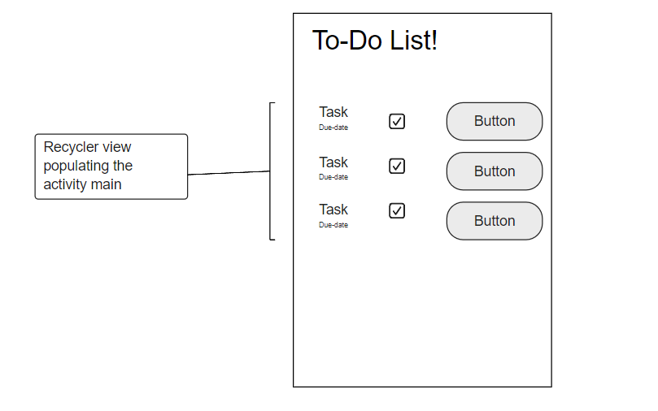

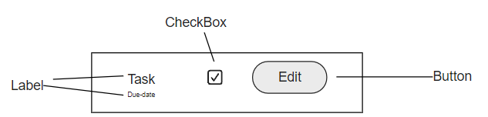

* There is only one label in here for heading rest of the list comes from recycler view
* In the base xml for recycler view 2 labels (in vertical layout) check box and button in horizontal layout are used no margin & padding required
* In the view that is used as base for recycler view there are 2 labels, one button and one checkbox
* Label textsize for task is 14sp and for due date is 7 sp
* There is checkbox for indicating the status of task.
* Edit button is for editing any task
* Using recycler view in here to create a list view of the data no margin padding needed and title is of 45sp

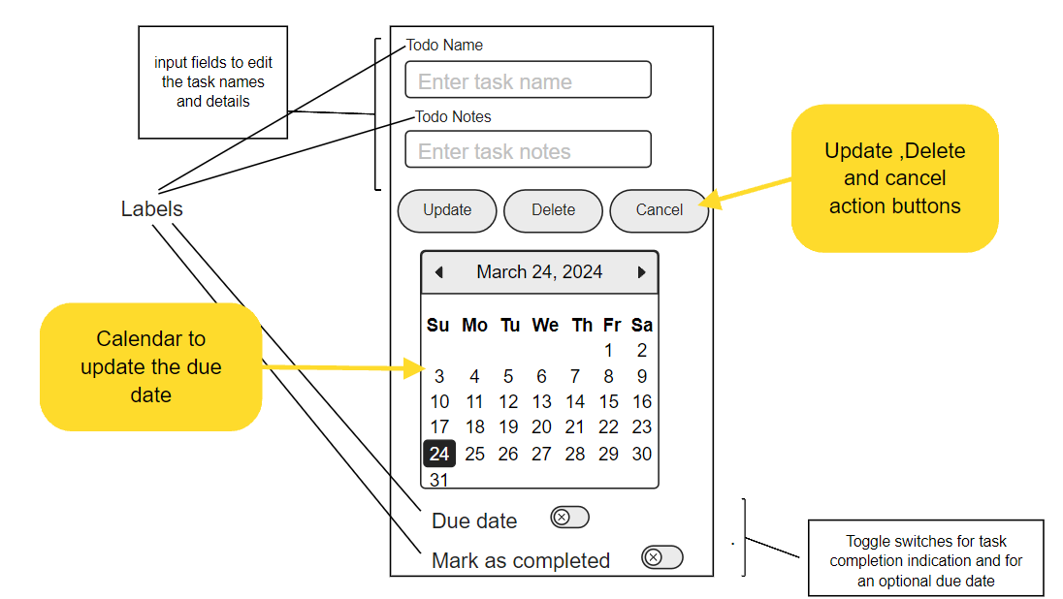

* There are two text input field to enter task name and it’s notes (details).
* There is update button to update any existing data of task, delete button to delete and cancel button will take to To-Do-List screen.
* Calendar view for displaying due date.
* Toggle switches for optional due date and task completion status to show the status of task and if they want a due date or not.
* Using Relative layout so margin and padding not needed all labels are of 15sp

ToDoApp Design-2

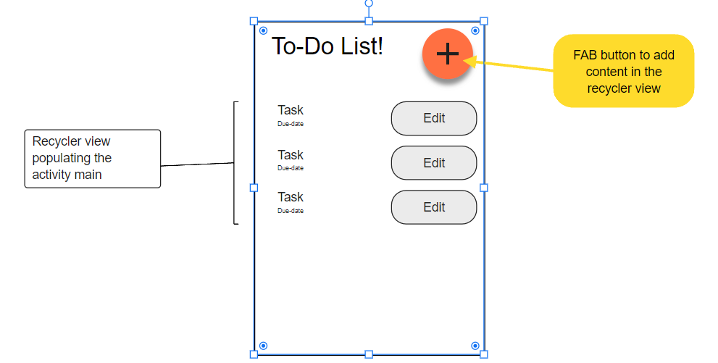

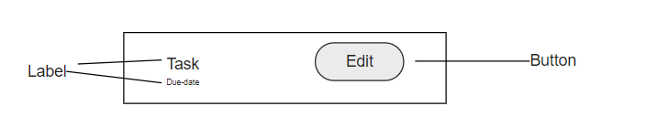

* There is one label and a FAB used here in the heading and rest of it comes from recycler view
* In the mainactiviity xml add FAB button which will open tododetails xml file when clicked used to add new data
* In the base xml for recycler view 2 labels one for task name and other is for due date being 20sp and 15sp respectively, font-family: monospace (in vertical layout) and button in horizontal layout is used no margin & padding required
* Gestures will be used for status of the tasks
* Edit button is for editing any task
* Using recycler view in here to create a list view of the data no margin padding needed and title is of 60sp

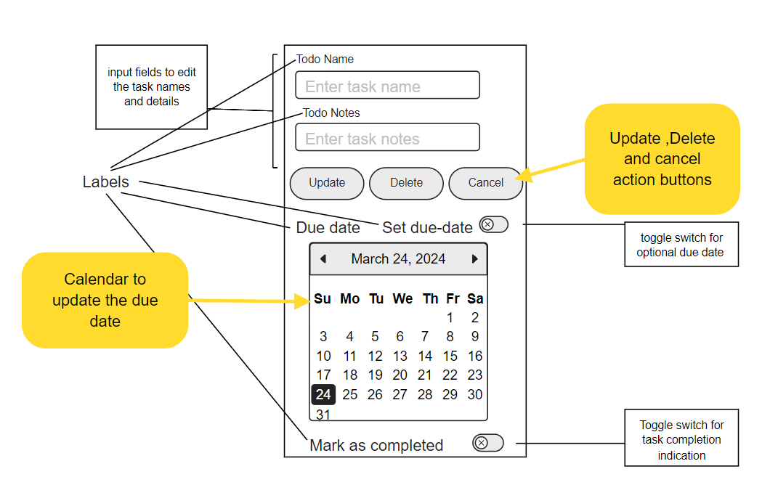

* There are two text input field to enter task name and it’s notes (details).
* There is update button to update any existing data of task, delete button to delete and cancel button will take to To-Do-List screen.
* Calendar view for displaying due date.
* Toggle switches for optional due date and task completion status to show the status of task and if they want a due date or not.
* Using Relative layout so margin and padding not needed all labels are of 18sp
* Font-Family used for every text is monospace

Winning design

Design 2 is the winning design

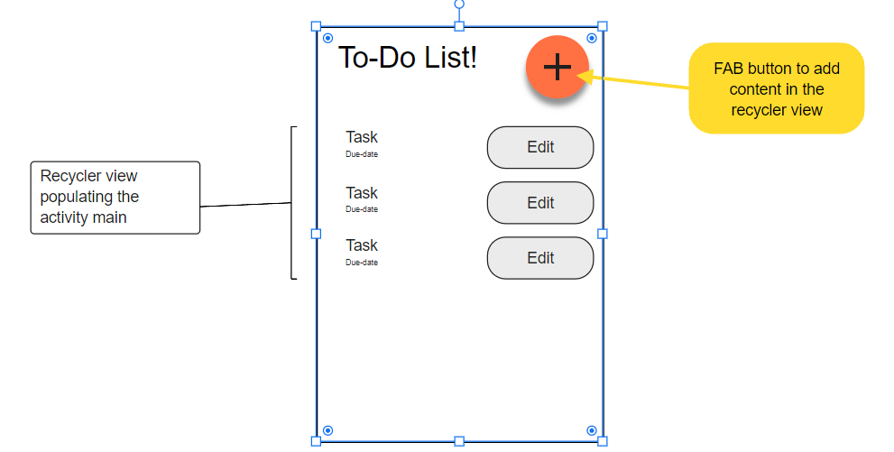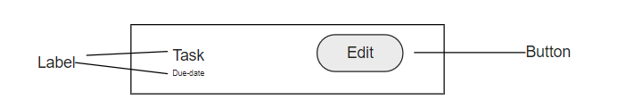



Colour splotches used for this design: background:#ffff99 ,buttons:#ffa500 , FAB colour: #A500FF and button text:#000000

Winning design with colour

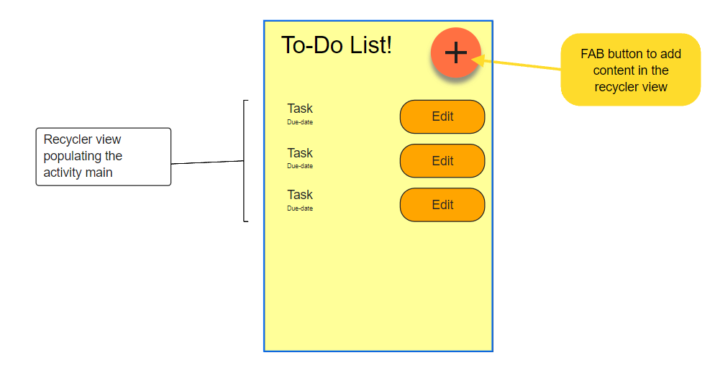 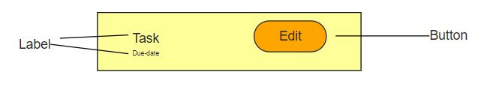

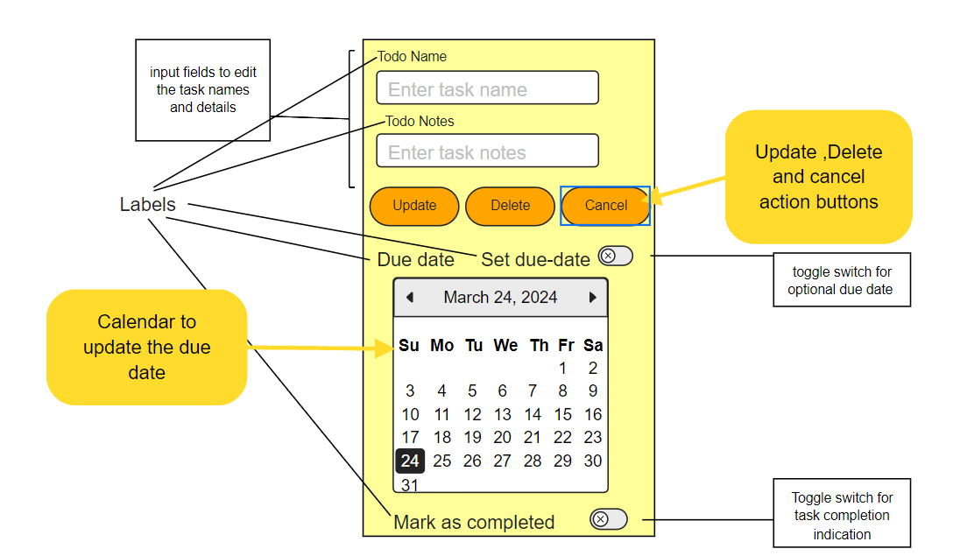

UI Design Image

